**Lab-3**

Task#1

**1-** ARP, SSDP, DHCP, MDNS, HTTP

**2- (**HTTP GET**)**4.718993 – **(**HTTP OK**)**4.694850 **=** 0.024143



**3-** Second **GET** request was not successful because there is 404 error in response packet



**4-** HTTP 1.1version is running in the server



**5-** Browser indicates EN-US language

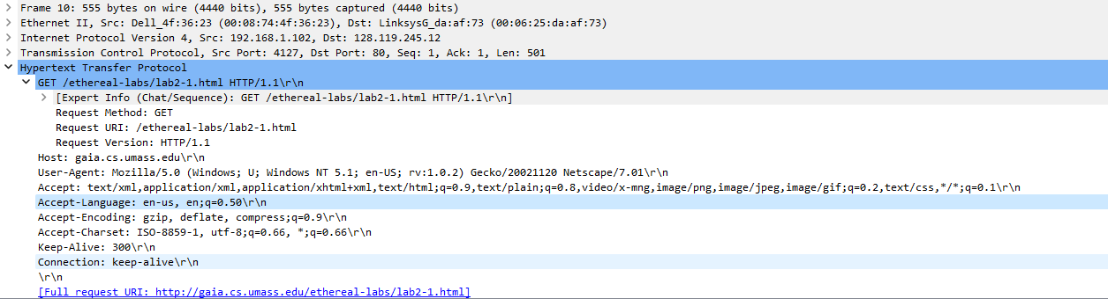

**6-** Gaia.cs: 128.119.245.12, My computer: 10.103.109.37

**7-**



**8-** Port 80 is the port number assigned to HTTP. It is the default network port used to send and receive unencrypted web pages.

**9-** Status Code 200

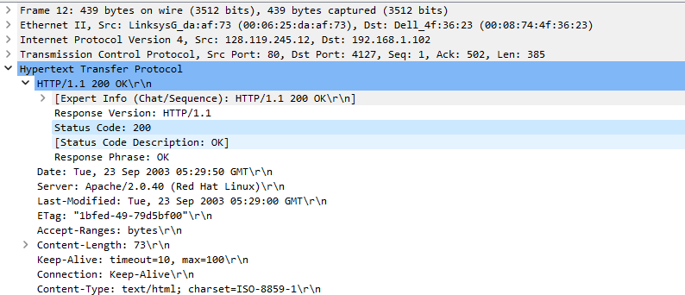

**10- Last-Modified:** Tuesday, 23 September 2003

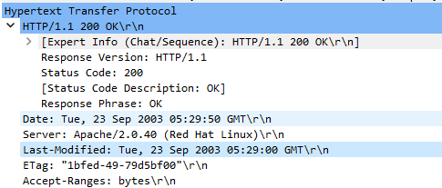

**11-** Content-Length: 73\r\n

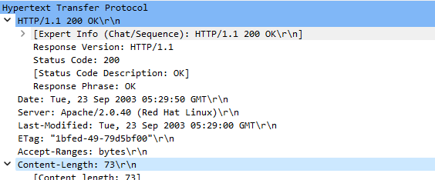

Task#2

**1-** No

**2-** Yes because we can see the contents in the Line-based text data field

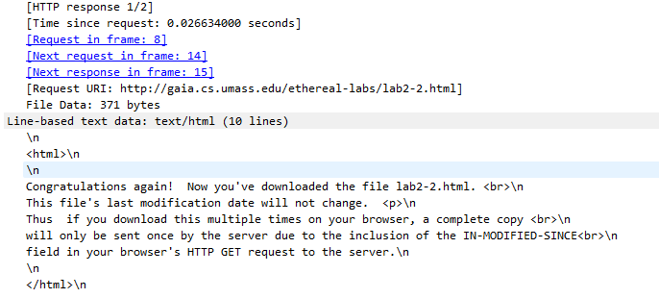

**3-** Yes. The information followed is: Tue, 12 Sep 2003 which is the date of the last modification of the file from the previous get request.

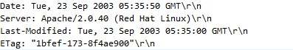

**4-** The status code and phrase returned from the server is HTTP/1.1 304 Not Modified. The server didn’t return the contents of the file since the browser loaded it from its cache.

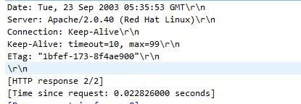

Task#3

**5-** There was 1 HTTP GET request message sent by my browser.

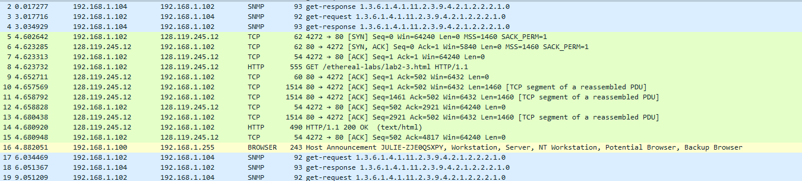

**6-** 14 packet number in the trace contains the GET message for The Bill of Rights

**7-** 14 packet number in the trace contains the status code and phrase associated with the response to the HTTP GET request

**8-**

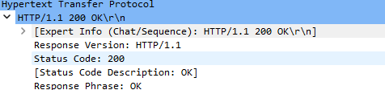

**9-** 5 TCPs, 9 to 13